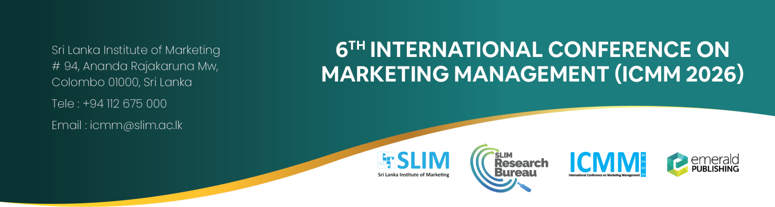

Registration Form

Section 1: Presenting Author Details

Name of the presenting author:
(as required on certificate)
Title: Prof ☐ Dr ☐ Mr ☐ Ms ☐ (Please insert “X” mark in the relevant box)
Email Address:
Affiliated Institution/ Organisation:
Address of the Institution:
Contact Number:
WhatsApp contact preferred (if available)
Mark Your Role in the submitted conference paper (Please insert “X” mark in the relevant box)
Corresponding Author (International) ☐
Corresponding Author (Local) ☐
Co-Author (International) ☐
Co-Author (Local) ☐

Section 2: Other Author Details (Include the details of all other authors except the presenting author's details below)

Title (Prof. / Dr / Mr / Ms) | Name  (as required on certificate) | Affiliated Organization / Institution | Role  (Please insert “X” mark in  the relevant box)
Title (Prof. / Dr / Mr / Ms) | Name  (as required on certificate) | Affiliated Organization / Institution | Corresponding Author (International) | Corresponding Author (Local) | Co-author (International) | Co-author (Local)

Registration Fees:
- Local Participant – LKR 5,000
- Foreign Participant – USD 30

Note:

- Local presenting authors must pay LKR 5,000, while foreign presenting authors must pay USD 30, for conference presentation registration.
- If any co-author attends the conference along with the presenting author must also pay the applicable registration fee (LKR 5,000 / USD 30), as fees are charged per person.
- Please make your registration fee payment to the account below and send the completed registration form, the author declaration form, and the payment slip to iresha.h@slim.ac.lk

Bank Details:
Account Name: Sri Lanka Institute of Marketing
Bank: People’s Bank
Branch Address: No. 715, Maradana Road, Colombo 10
Account No: 2361 0013 0002 551
SWIFT Code: PSBKLKLX

